Name (netid): Sairamasubash Muppalaneni (smuppa3)
CS 441 - HW 4: Dealing with Data

Complete the claimed points and sections below.

Total Points Claimed [127] / 142

- Clustering and Fast Retrieval
  - Test Kmeans Purity & Centroids [15] / 15
  - Questions [10] / 10
  - Fast 1-NN Retrieval [15] / 15
- Estimating PDFs
  - Histograms [10] / 10
  - Clustering [10] / 10
  - Gaussian Mixture Model [15] / 15
- PCA and Data Compression
  - Display Principal Components [5] / 5
  - Scatter Plot [5] / 5
  - Plot cumulative explained variance [5] / 5
  - Time & Accuracy [10] / 10
- Stretch Goals
  - Rotate Using PCA and comparison
To original approach [0] / 15
  - Try Part 2 with your own images [10] / 10
  - Plot Using t-SNE and MDS [15] / 15
  - Completed HW3 survey by DATE [2] / 2

1. Clustering & Fast Retrieval
K Vs Purity Plot | K Vs Mean_Distance Plot
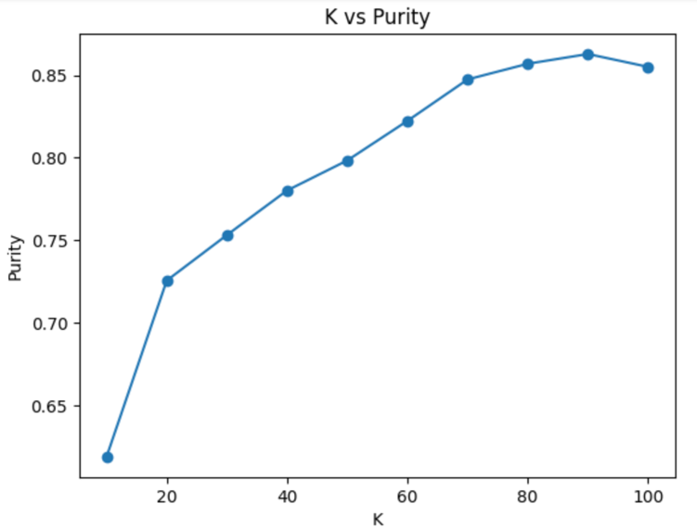 | 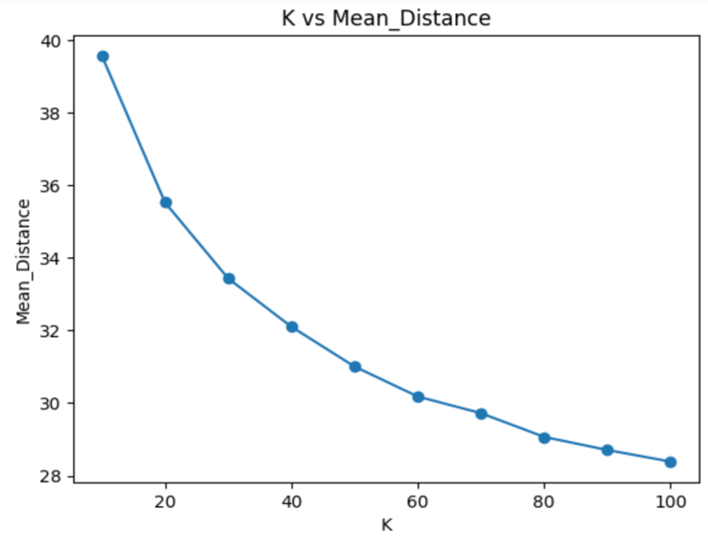
- Test KMeans Purity [15]

Paste images of centroids for K = 10, K = 20, and K=30 below (three rows).
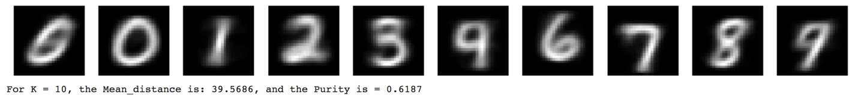

Experimenting with niter, and nredo: The images of the plots and the images of the centroids above are the results that I got when I did not use the niter and nredo parameters with the k-means clustering object. When I did use the the niter and nredo parameters with the k-means clustering object, I noticed that the mean distance reduces, and the purity increases as the values of niter and nredo go up.

- Questions [10]

  - As you increase K, do you expect the purity to increase? Why or why not?

As I increase K, I expect the purity to increase. I don’t expect the purity to always increase by a lot, but I do expect the purity to always increase at least a little. I say this because the more samples there are, the more likely it is that the images that look similar will be clustered together. Which will lead to an increase in purity. However, based on the K VS Purity plot above, as K increases, the purity doesn’t always increase. Most of the time the purity increased, but when K was equal to 100, the purity decreased. I think this is due to overfitting.

  - In a given run, is the average distance of a sample to centroid guaranteed to monotonically decrease with each iteration (i.e. cannot increase)? Why or why not?

Yes, in a given run, the average distance of a sample to centroid is guaranteed to monotonically decrease (or not change) with each iteration. I say this because I believe that with each iteration, the k-means algorithm decreases the sum of squared distances from each point to the centroid that it is related to. Basically, the centroids are allocated closer towards the average of the samples in every single cluster. So, the average distance will always decrease, or the average distance will not change. An example of this is shown in the K VS Mean_Distance plot above.

  - If you do enough iterations, is Kmeans guaranteed to give you the optimal clustering that minimizes the sum of distances between each sample and its center? Why or why not?

If I do enough iterations, the k-means algorithm is not guaranteed to give me the optimal clustering that minimizes the sum of distances between each sample and its center. I say this because the k-means algorithm is sensitive when it comes to the centroids that have just been placed. Although the k-means algorithm is guaranteed to find the local optimum that minimizes the sum of distances between each sample and its center, it is not guaranteed to find the global optimum that minimizes the sum of distances between each sample and its center.

  - Does improving the Kmeans objective (i.e. achieving lower mean squared error) necessarily improve expected purity? Why or why not?

Improving the k-means objective does not necessarily improve the expected purity. I say this because, the k-means objective is to achieve a lower mean squared error. When we achieve a lower mean squared error, the clusters will become smaller. In other words, the clusters will become denser. When this happens, there is a possibility that samples from different clusters that are close to one another will be grouped together. Due to this, improving the K-means objective does not necessarily mean that the purity will improve.

- Fast Retrievals
  - Brute Force: [5]
Test Error | Time to Add | Time to Search
0.0331 | 0.1038s | 11.5235s
  - LSH: [5]
Test Error | Time to Add | Time to Search | Nbits parameter
0.0318 | 1.8540s | 12.0551s | 1568 (ndim*2)

For LSH, when I did ndim: The nbits Is: 784, The Test Error Is: 0.0373, The Add Time Is: 0.9650s, The Search Time Is: 5.6733s

For LSH, when I did ndim/2: The nbits Is: 392, The Test Error Is: 0.0425, The Add Time Is: 0.5031s, The Search Time Is: 3.9151s

2. Estimating PDFs
Include the generated images (score map, thresholded score map, thresholded RGB) from the display code.
- Histogram: [10]

I assume that histogram is the Per-dimension discrete pdf.

Here are the parameters that I am using for Per-dimension discrete pdf:
K = 13
Treshold = 0.6

Here are the images that I got for Per-dimension discrete pdf:
The Regular Image: The Score Map:
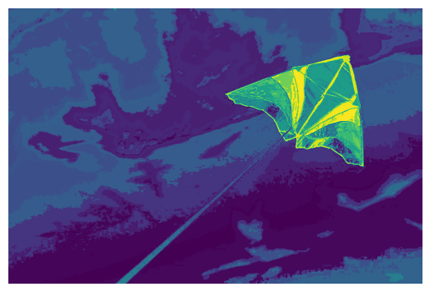

The Thresholded Score Map: The Thresholded RGB:
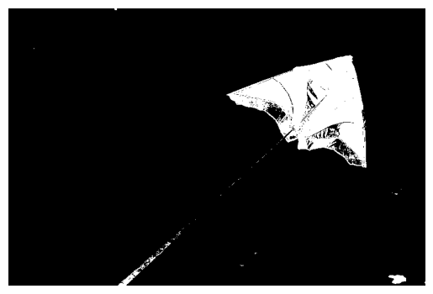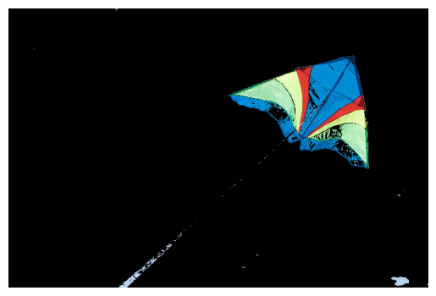
- Clustering: [10]

Here are the parameters that I am using for K-means:
K = 501
Treshold = 0.6

Here are the images that I got for K-means:
The Regular Image: The Score Map:
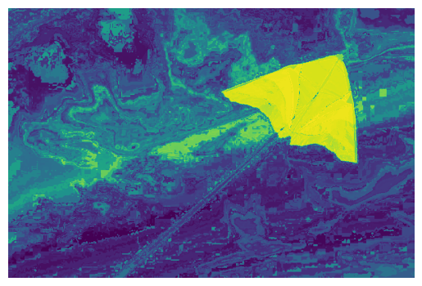

The Thresholded Score Map: The Thresholded RGB:
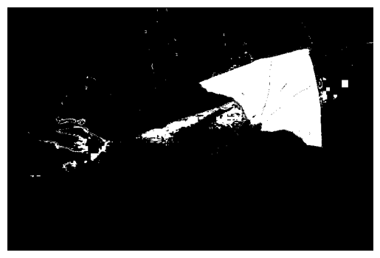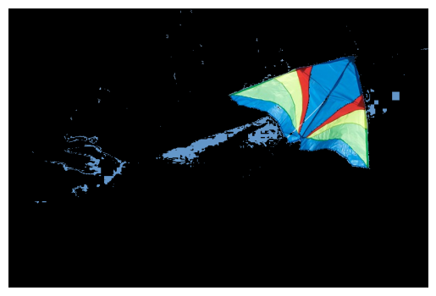

- Gaussian mixture Model: [15]

Here are the parameters that I am using for GMM:
n_components = 8
covariance_type = ‘full’
Treshold = 0.6

Here are the images that I got for GMM:
The Regular Image: The Score Map:
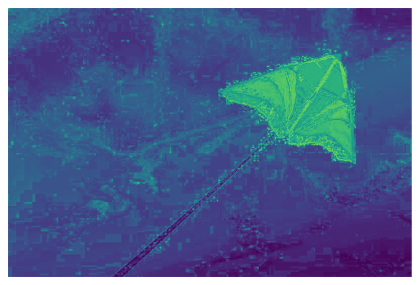

The Thresholded Score Map: The Thresholded RGB:
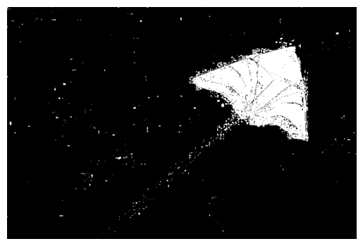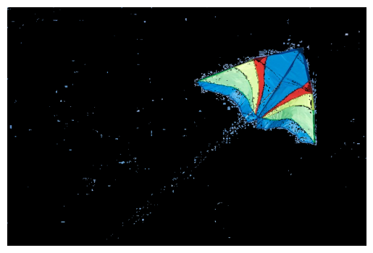

3. PCA and Data Compression

- First 10 principal components [5]

Visualization

- Scatterplot [5]

PLOT
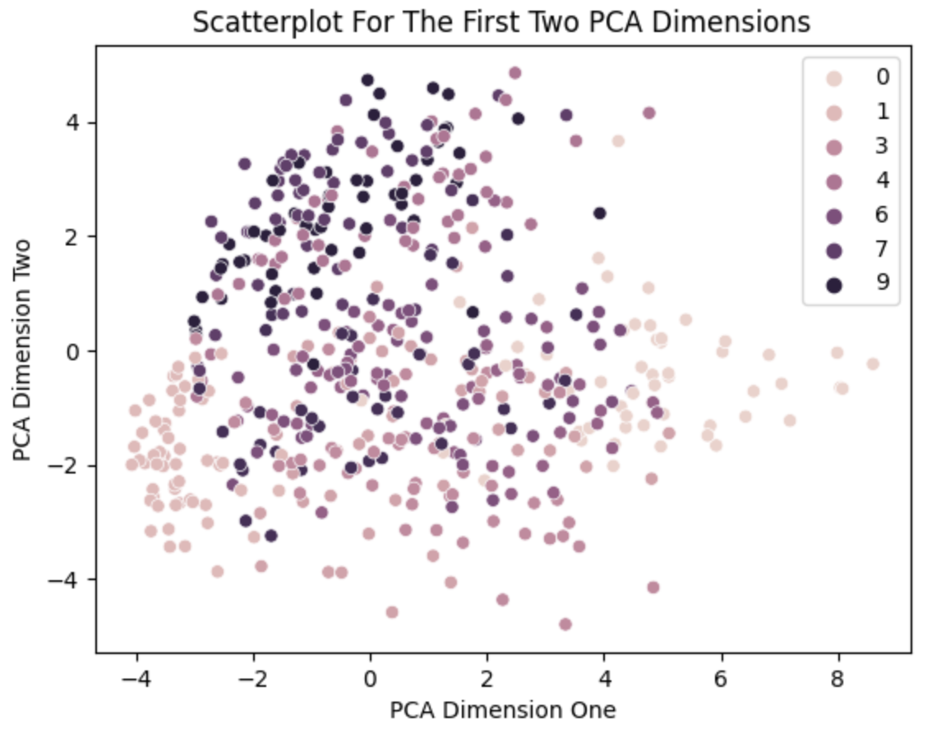

- Cumulative explained Variance [5]

PLOT
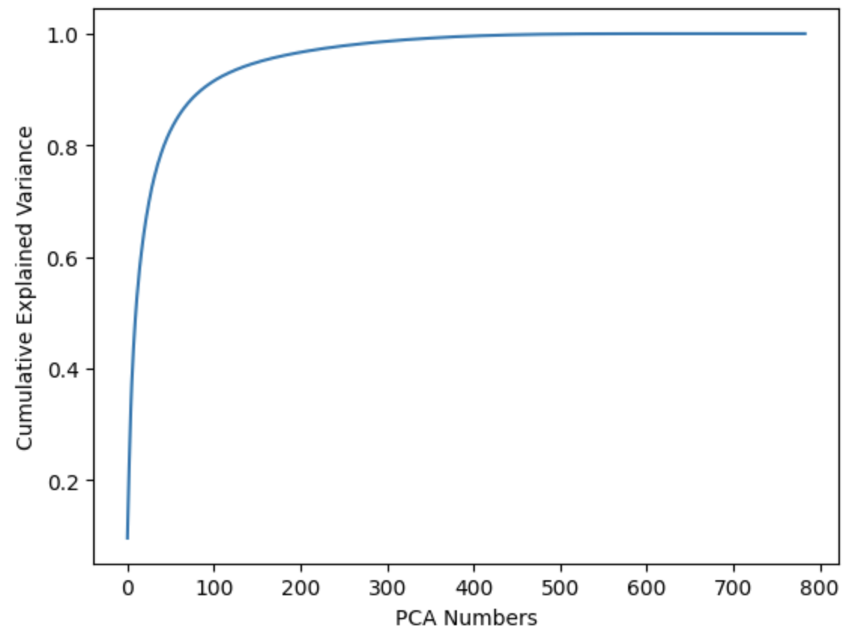

- Faiss [10]

 | Total Time | Test Error | Dimensions
Brute Force (PCA) | 2.6336s | 0.0286 | 88
Brute Force | 11.6273s | 0.0331 | 768
LSH | 6.6383s | 0.0373 | 768
Note: the last two rows are copied from 1.c for reference.

Comparing PCA Brute Force With Regular Brute Force And Regular LSH:

The total time is less for PCA Brute Force when compared to regular Brute Force and regular LSH. Moreover, the test error is less for PCA Brute Force when compared regular Brute Force and regular LSH. Also, I believe that the dimensions for regular Brute Force and regular LSH (without using PCA) is 784 and not 768 (which is what it says in the table above).

4. Stretch Goals
- PDFS after using PCA to rotate your data [15]

- Apply Part 2 to your own choice of image, with the same deliverables [10]

Here is the new image:



Here is the new cropped image:



New Image Histogram:
I assume that histogram is the Per-dimension discrete pdf.

Here are the parameters that I am using for Per-dimension discrete pdf:

K = 13
Treshold = 0.6

Here are the images that I got for Per-dimension discrete pdf:
The Regular Image: The Score Map:
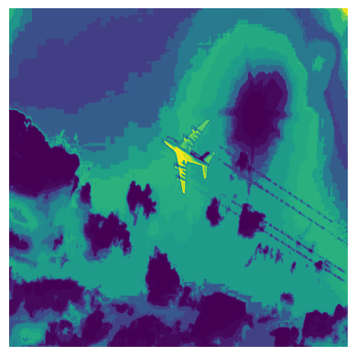

The Thresholded Score Map: The Thresholded RGB:
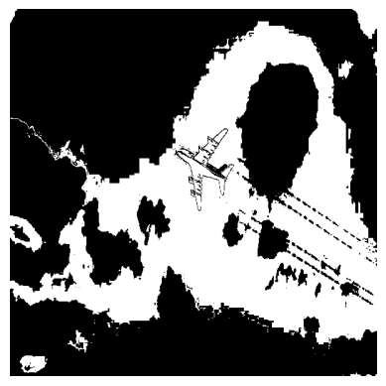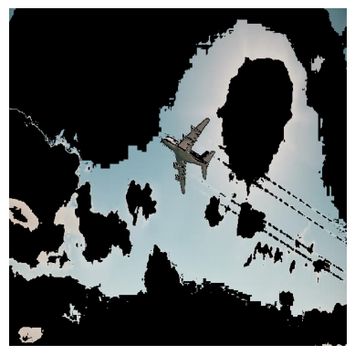

New Image Clustering:

Here are the parameters that I am using for K-means:
K = 501
Treshold = 0.6

Here are the images that I got for K-means:
The Regular Image: The Score Map:
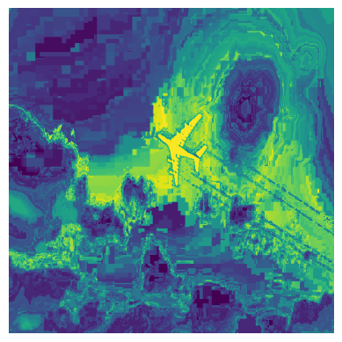

The Thresholded Score Map: The Thresholded RGB:
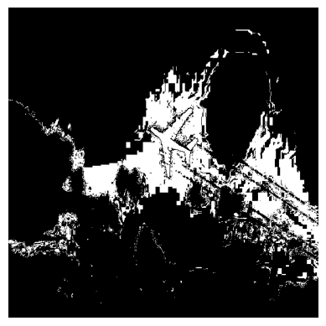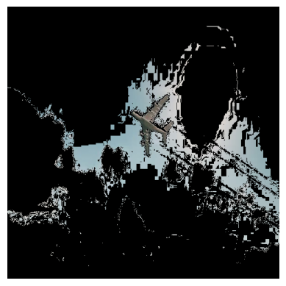

New Image Gaussian mixture Model:
Here are the parameters that I am using for GMM:

n_components = 8
covariance_type = ‘full’
Treshold = 0.6

Here are the images that I got for GMM:
The Regular Image: The Score Map:
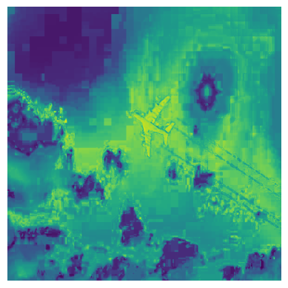

The Thresholded Score Map: The Thresholded RGB:

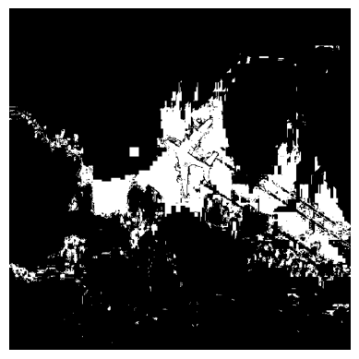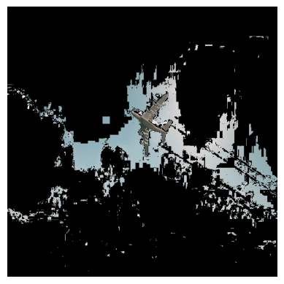

- Scatterplots using at least two of t-SNE, MDS, and Linear Discriminant Analysis [15]
PCA Scatterplot:
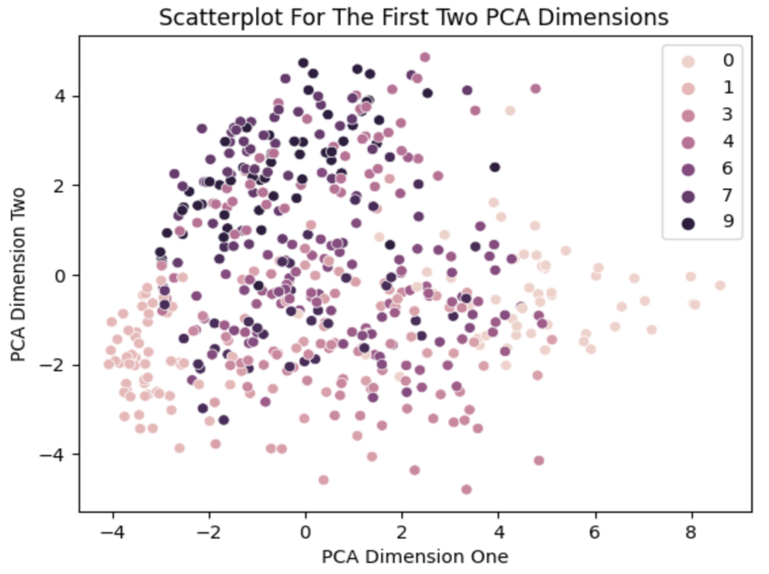

t-SNE Scatterplot:
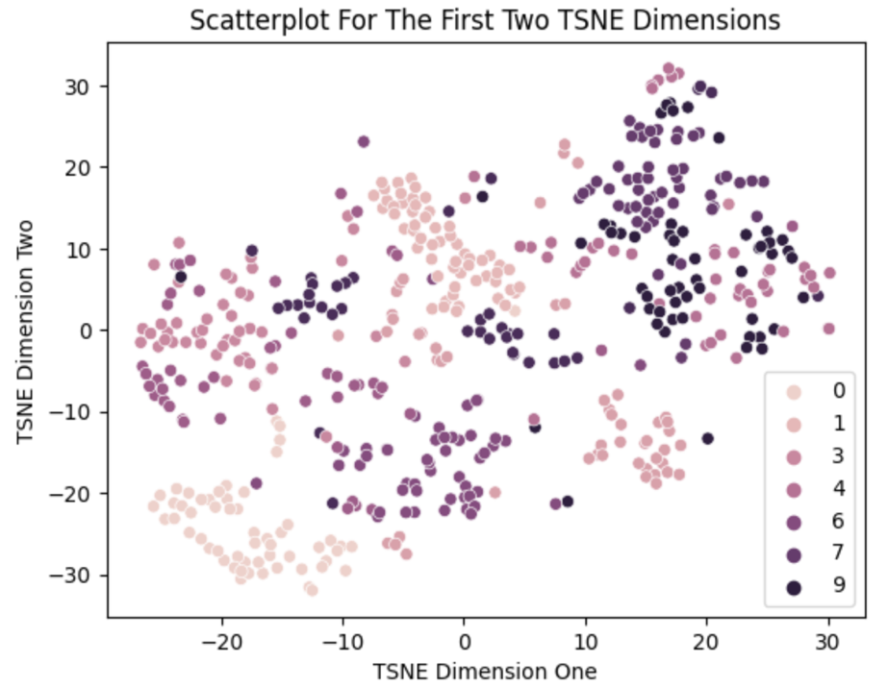

MDS Scatterplot:
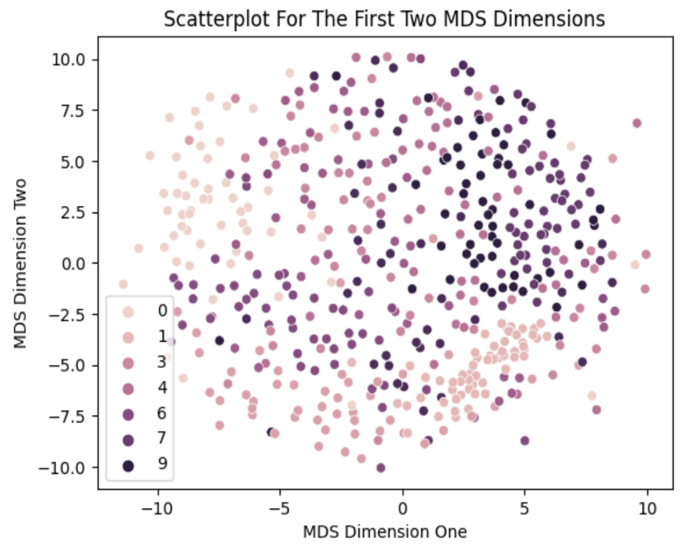

Linear Discriminant Analysis Scatterplot:
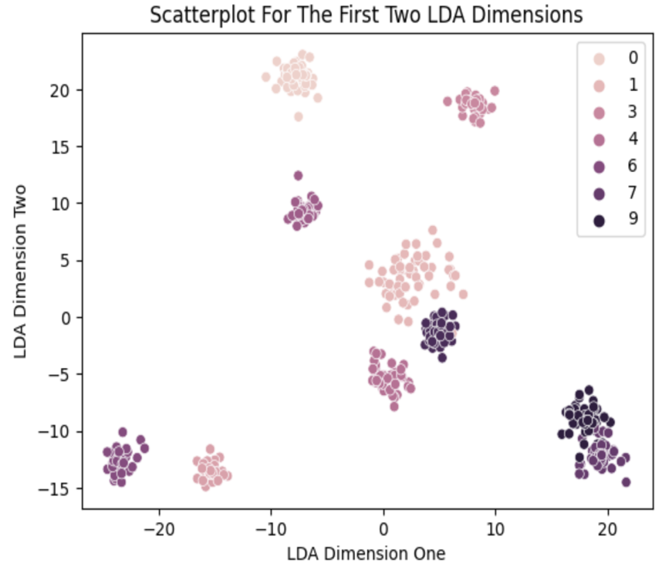

Acknowledgments / Attribution

List any outside sources for code or improvement ideas or “None”.

Sources:

- Course Lectures/Slides
- w3schools
- https://faiss.ai
- https://faiss.ai/cpp_api/struct/structfaiss_1_1Clustering.html
- https://github.com/facebookresearch/faiss/wiki/Faiss-indexes
- https://github.com/facebookresearch/faiss/wiki/Faiss-building-blocks:-clustering,-PCA,-quantization
- https://faiss.ai/cpp_api/struct/structfaiss_1_1IndexLSH.html
- https://www.flickr.com/photos/vironevaeh/3985783648
- https://scikit-learn.org/stable/modules/generated/sklearn.mixture.GaussianMixture.html
- https://scikit-learn.org/stable/modules/generated/sklearn.decomposition.PCA.html
- https://numpy.org/doc/stable/reference/generated/numpy.ndarray.flatten.html
- https://scikit-learn.org/stable/modules/mixture.html

Improvement Ideas:

- The only improvement idea that I can think of is providing expected results so that I know if the results that I get are correct.

